FIN 525: Investment Strategies

Practice Final Exam

Excluding Case Study-related Questions

Name: ……………………………………………………………………………………...

Instructions:
- Allowed materials: A basic scientific or financial calculator, and a writing utensil (pencil).
- You are allowed to use self-prepared max. 4-page formula/note sheet for the exam (8.5”x11”). The exam is closed book.
- For the 30 multiple-choice questions, please answer on the provided Scantron form. Mark the bubbles fully and clearly using your pencil. Add your name and ID to the form as well.
- All multiple-choice questions are weighted equally (one point each question).
- You will have 90 minutes to complete this Final Exam.
- The ASU Academic Integrity Policy will be strictly observed.
________________________________________________________________________

Multiple-Choice Questions. Please select the most correct answer.

1. The Sharpe, Treynor, and Jensen portfolio performance measures are derived from the CAPM,
A. | therefore, it does not matter which measure is used to evaluate a portfolio manager.

B. | however, the Sharpe and Treynor measures use different risk measures; therefore, the measures vary as to whether or not they are appropriate, depending on the investment scenario.

C. | therefore, all measure the same attributes.

D. | therefore, it does not matter which measure is used to evaluate a portfolio manager; however, the Sharpe and Treynor measures use different risk measures, so therefore, the measures vary as to whether or not they are appropriate, depending on the investment scenario.

E. | None of the options
The Sharpe measure uses standard deviation, or total risk, as the risk measure; the Treynor measure uses beta, or systematic risk, as the risk measure.

2. A portfolio manager's ranking within a comparison universe may not provide a good measure of performance because
A. | portfolio returns may not be calculated in the same way.

B. | portfolio durations can vary across managers.

C. | if managers follow a particular style or subgroup, portfolios may not be comparable.

D. | portfolio durations can vary across managers and if managers follow a particular style or subgroup, portfolios may not be comparable.

E. | All of the options
Returns are typically time weighted for all portfolios, and broad risk classes or styles are grouped together; but particular subgroups and differences in duration are typically not considered.

3. The Jensen portfolio evaluation measure
A. | is a measure of return per unit of risk, as measured by standard deviation.

B. | is an absolute measure of return over and above that predicted by the CAPM.

C. | is a measure of return per unit of risk, as measured by beta.

D. | is a measure of return per unit of risk, as measured by standard deviation and is an absolute measure of return over and above that predicted by the CAPM.

E. | is an absolute measure of return over and above that predicted by the CAPM and is a measure of return per unit of risk, as measured by beta.
A measure of return per unit of risk, as measured by standard deviation is the Sharpe measure; a measure of return per unit of risk, as measured by beta is the Treynor measure.

4. In a particular year, Aggie Mutual Fund earned a return of 15% by making the following investments in the following asset classes:
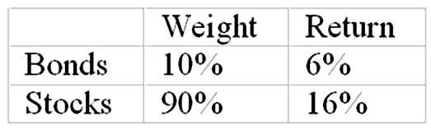
The return on a bogey portfolio was 10%, calculated as follows:
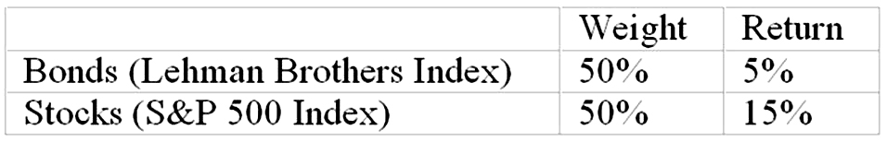
The contribution of selection within markets to total excess return was
A. | 1%.

B. | 3%.

C. | 4%.

D. | 5%.
See table below.
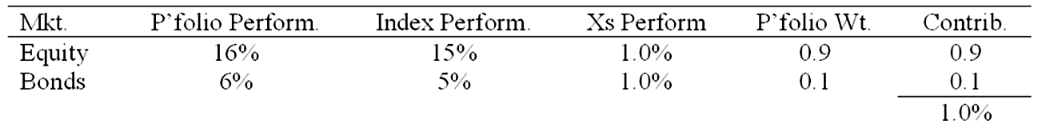

5. In a particular year, Aggie Mutual Fund earned a return of 15% by making the following investments in the following asset classes:
The return on a bogey portfolio was 10%, calculated as follows:
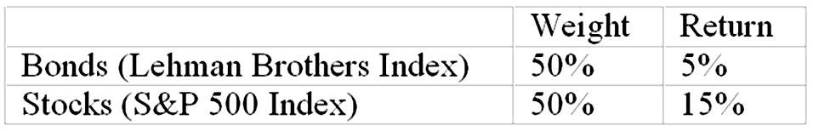
The contribution of asset allocation across markets to the total excess return was
A. | 1%.

B. | 3%.

C. | 4%.

D. | 5%.
See table below.
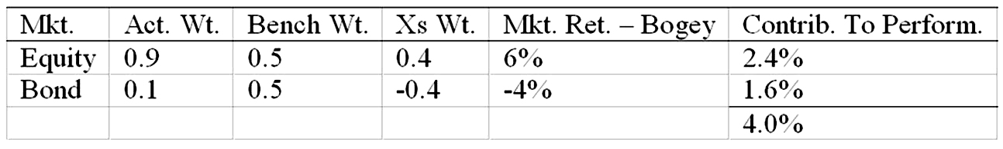

6. If an investor has a portfolio that has constant proportions in T-bills and the market portfolio, the portfolio's characteristic line will plot as a line with ___________; if the investor can time bull markets, the characteristic line will plot as a line with ___________.
A. | a positive slope; a negative slope

B. | a negative slope; a positive slope

C. | a constant slope; a negative slope

D. | a negative slope; a constant slope

E. | a constant slope; a positive slope
These characteristics are shown in Figure 24.5. If the proportions are constant the beta of the portfolio stays constant. If the investor switches the proportions in favor of the marker portfolio to take advantage of bull markets the beta will increase during times of higher market risk premiums. This will cause the slope of the curve to increase.

7. The following data are available relating to the performance of Seminole Fund and the market portfolio:
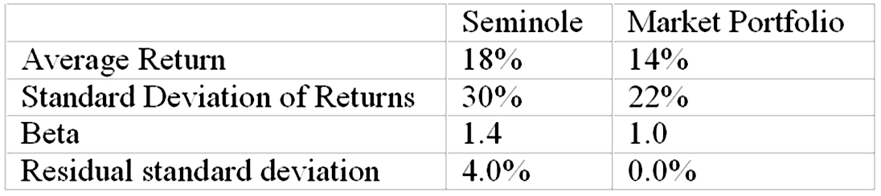
The risk-free return during the sample period was 6%.
If you wanted to evaluate the Seminole Fund using the M ² measure, what percent of the adjusted portfolio would need to be invested in T-Bills?
A. | -36% (borrow)

B. | 50%

C. | 8%

D. | 36%

E. | 27%
22/30 = .7333, or 73.33% invested in Seminole Fund and 1 - 73.33% = 26.67% in T-Bills.
8. Suppose the risk-free return is 3%. The beta of a managed portfolio is 1.75, the alpha is 0%, and the average return is 16%. Based on Jensen's measure of portfolio performance, you would calculate the return on the market portfolio as
A. | 12.3%.

B. | 10.4%.

C. | 15.1%.

D. | 16.7%.
0% = 16% - [3% + 1.75(x - 3%)]; x = 10.4%.

9. Most professionally managed equity funds generally
A. | outperform the S&P 500 Index on both raw and risk-adjusted return measures.

B. | underperform the S&P 500 Index on both raw and risk-adjusted return measures.

C. | outperform the S&P 500 Index on raw return measures and underperform the S&P 500 Index on risk-adjusted return measures.

D. | underperform the S&P 500 Index on raw return measures and outperform the S&P 500 Index on risk-adjusted return measures.

E. | match the performance of the S&P 500 Index on both raw and risk-adjusted return measures.
Most mutual funds do not consistently, over time, outperform the S&P 500 Index on the basis of either raw or risk-adjusted return measures.

10. The risk profile of hedge funds ______, making performance evaluation ______.
A. | can shift rapidly and substantially; challenging

B. | can shift rapidly and substantially; straightforward

C. | is stable; challenging

D. | is stable; straightforward

E. | None of the options
The risk profile of hedge funds can shift rapidly and substantially, making performance evaluation challenging.

11. Hedge fund incentive fees are essentially
A. | put options on the portfolio with a strike price equal to the current portfolio value.

B. | put options on the portfolio with a strike price equal to the expected future portfolio value.

C. | call options on the portfolio with a strike price equal to the expected future portfolio value.

D. | call options on the portfolio with a strike price equal to the current portfolio value times one plus the benchmark return.

E. | straddles.
Hedge fund incentive fees are essentially call options on the portfolio with a strike price equal to the current portfolio value times one plus the benchmark return.

12. Performance evaluation of hedge funds is complicated by
A. | liquidity premiums.

B. | survivorship bias.

C. | unreliable market valuations of infrequently traded assets.

D. | unstable risk attributes.

E. | All of the options

Performance evaluation of hedge funds is complicated by liquidity premiums, survivorship bias, unreliable market valuations of infrequently traded assets, and unstable risk attributes.

13. Assume that you manage a $2 million portfolio that pays no dividends and has a beta of 1.3 and an alpha of 2% per month. Also, assume that the risk-free rate is 0.05% (per month) and the S&P 500 is at 1,500. If you expect the market to fall within the next 30 days you can hedge your portfolio by ______ S&P 500 futures contracts (the futures contract has a multiplier of $250).
A. | selling 1

B. | selling 7

C. | buying 1

D. | buying 7

E. | selling 11
The hedge ratio is [$2M/(1500 × 250)] × 1.3 = 6.93. Thus, you would need to sell 7 contracts.

14. If the yield on mortgage-backed securities was abnormally low compared to Treasury bonds, a hedge fund pursuing a relative value strategy would
A. | short sell the Treasury bonds and short sell the mortgage-backed securities.

B. | short sell the Treasury bonds and buy the mortgage-backed securities.

C. | buy the Treasury bonds and buy the mortgage-backed securities.

D. | buy the Treasury bonds and short sell the mortgage-backed securities.
If the yield on mortgage-backed securities was abnormally low compared to Treasury bonds, a hedge fund pursuing a non-directional strategy would buy the Treasury and short sell the mortgage-backed securities.

15. A hedge fund pursuing a ______ strategy is trying to exploit relative mispricing within a market, but is hedged to avoid taking a stance on the direction of the broad market.
A. | directional

B. | nondirectional

C. | market neutral

D. | arbitrage or speculation

E. | nondirectional and market neutral
A hedge fund pursuing a market neutral strategy is trying to exploit relative mispricing within a market, but is hedged to avoid taking a stance on the direction of the broad market.

16. Consider the Treynor-Black model. The alpha of an active portfolio is 2%. The expected return on the market index is 12%. The variance of the return on the market portfolio is 4%. The nonsystematic variance of the active portfolio is 2%. The risk-free rate of return is 3%. The beta of the active portfolio is 1.15. The optimal proportion to invest in the active portfolio is
A. | 48.7%.

B. | 98.3%.

C. | 47.6%.

D. | 100.0%.
w^{O} = [2%/2%]/[(12% - 3%)/4%] = 0.444; w* = 0.444/[1 + (1 - 1.15) 0.444] = .476, or 47.6%.

17. The beta of an active portfolio is 1.45. The standard deviation of the returns on the market index is 22%. The nonsystematic variance of the active portfolio is 3%. The standard deviation of the returns on the active portfolio is
A. | 36.30%.

B. | 5.84%.

C. | 19.60%.

D. | 24.17%.

E. | 26.0%.
s = [(1.45)²(0.22)² + 0.03]^{1/2} = [0.13176]^{1/2} = 36.3%.

18. Consider the Treynor-Black model. The alpha of an active portfolio is 3%. The expected return on the market index is 18%. The standard deviation of the return on the market portfolio is 25%. The nonsystematic standard deviation of the active portfolio is 15%. The risk-free rate of return is 6%. The beta of the active portfolio is 1.2. The optimal proportion to invest in the active portfolio is
A. | 50.0%.

B. | 69.4%.

C. | 72.3%.

D. | 80.6%.

E. | 100.0%.
w^{O} = [3%/2.25%]/[(18% - 6%)/6.25%] = 0.6944; w* = 0.6944/[1 + (1 - 1.2)0.6944] = 0.8064, or 80.6%.

19. The Treynor-Black model assumes that
A. | the objective of security analysis is to form an active portfolio of a limited number of mispriced securities.

B. | the cost of less than full diversification comes from the nonsystematic risk of the mispriced stock.

C. | the optimal weight of a mispriced security in the active portfolio is a function of the degree of mispricing, the market sensitivity of the security, and its degree of nonsystematic risk.

D. | All of the options

E. | None of the options

All of the statements correctly describe assumptions of the Treynor-Black model.

20. Consider these two investment strategies:
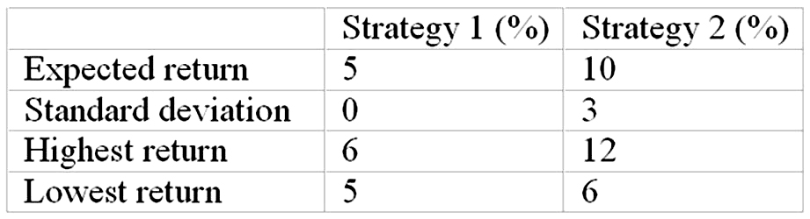
Strategy __________ is the dominant strategy because __________.
A. | 1; it is riskless

B. | 1; it has the highest reward/risk ratio

C. | 2; its return is at least equal to Strategy 1 and sometimes greater

D. | 2; it has the highest reward/risk ratio

E. | Both strategies are equally preferred.
Strategy 2 dominates strategy 1, even though it is riskier, because it always returns at least as much as strategy 1 and sometimes more.

21. There appears to be a role for a theory of active portfolio management because
A. | some portfolio managers have produced sequences of abnormal returns that are difficult to label as lucky outcomes.

B. | the "noise" in the realized returns is enough to prevent the rejection of the hypothesis that some money managers have outperformed a passive strategy by a statistically small, yet economic, margin.

C. | some anomalies in realized returns have been persistent enough to suggest that portfolio managers who identified these anomalies in a timely fashion could have outperformed a passive strategy over prolonged periods.

D. | some portfolio managers have produced sequences of abnormal returns that are difficult to label as lucky outcomes and the "noise" in the realized returns is enough to prevent the rejection of the hypothesis that some money managers have outperformed a passive strategy by a statistically small, yet economic, margin.

E. | All of the options

